

Fig 3

In the above figure, we have taken the eye haar cascade characterstics for accurately detecting the salient features of the face of a person. In the above lines of code we have taken the images if the faces of a person in a numpy array and then used the cascade classifier for detecting the eyes. For accurately detecting the eyes we convert the image of the person’s face into a grayscale image. Once the eyes are detected, a rectangle is drawn over their boundaries so as to display the detection of the eyes. Along with face detection , eye detection can improve the accuracy in determining a person’s face.

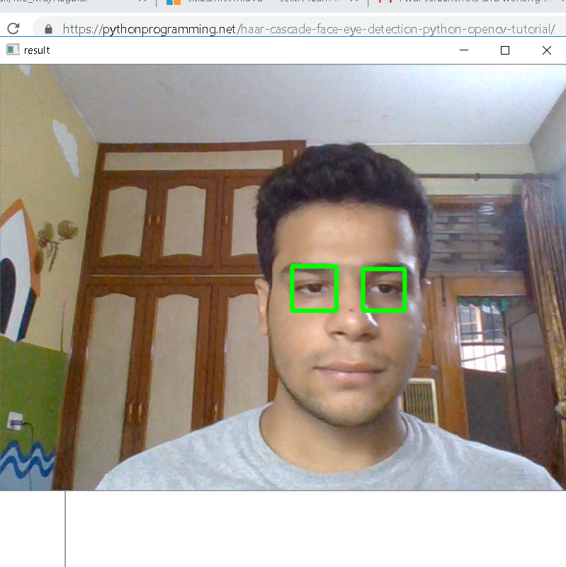

Fig 4

In the above figure we have successfully determined the eyes of the person. This eye detection will work irrespective of whether the person is wearing eyeglasses or not. Thus eye detection using opencv is faster and accurate than the traditional methods.